**Project Design Phase-II Data Flow Diagram &User Stories**

|  |  |
| --- | --- |
| Date | 16 October 2022 |
| Team ID | **PNT2022TMID25247** |
| Project Name | **AI-based discourse for Banking Industry** |
| Maximum Marks | 4 Marks |

# Data Flow Diagrams:

A Data Flow Diagram (DFD) is a traditional visual representation of the information flows within a system. A neat and clear DFD can depict the right amount of the system requirement graphically. It shows how data enters and leaves the system, what changes the information, and where data is stored.

# Example: [(Simplified)](https://developer.ibm.com/patterns/visualize-unstructured-text/)

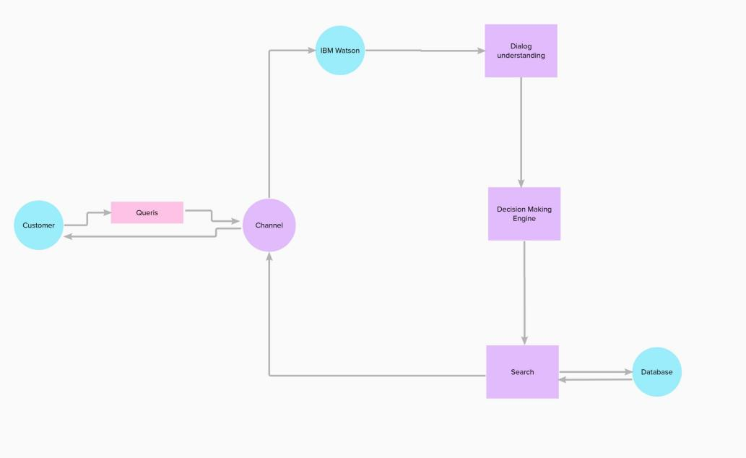

Example: DFD Level 0 (Industry Standard)

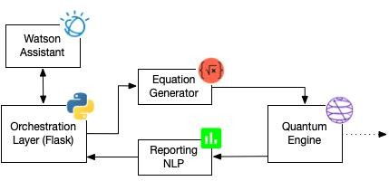

Database

**User Stories**

Use the below template to list all the user stories for the product.

|  |  |  |  |  |  |  |
| --- | --- | --- | --- | --- | --- | --- |
| **User Type** | **Functional Requirement (Epic)** | **User Story Number** | **User Story / Task** | **Acceptance criteria** | **Priority** | **Release** |
| Customer (Web user) | UI Design | USN-1 | As a user, I will view all icons,button,content | If the content will  properly viewing in all devices. | High | Sprint-1 |
|  | Whatsapp integration | USN-2 | If a user use for this chatbot through this whatapp | If any greeting word can  be given after it will help for you. | High | Sprint-2 |
|  | Improve Security | USN-3 | If a data will be hide for third persons | If a data can’t show  original message for third person | HIgh | Sprint-3 |
|  | messenger integration | USN-4 | If a user use for this chatbot through this messanger | If any greeting word can  be given after it will help for you. | Medium | Sprint-4 |
| Customer (Mobile user) | The functional requirements are same as a web  user | Same as a Web user | Same as a web user | Same as a web user | High when compared to  web users |  |